Dr. Micheál Ó Briain is passionate about nature and has been actively engaged in its conservation since his youth. For his studies of the birdlife of Rogerstown Estuary in County Dublin he was awarded the Young Scientist of the Year in 1977. Micheál carried out the first detailed studies of Irish wintering Brent Geese for his PhD at University College Dublin, which also involved three expeditions to the Canadian High Arctic. He then worked for the Irish Wildbird Conservancy (now BirdWatch Ireland), initially as its first Conservation Officer, then as National Director.
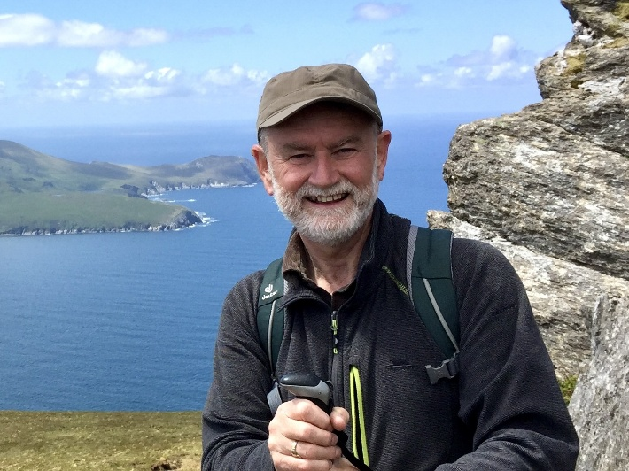
He spent almost 30 years working for the European Commission on EU and international nature and biodiversity policies, working closely with Ireland and other EU Member States, particularly on setting up Natura 2000, the EU wide network of protected areas. In September 2022 Micheál was honoured to receive BirdLife International’s President’s Medal, its highest award, in recognition of his contribution to bird conservation in Europe.
Since retiring, Micheál continues to support initiatives for the conservation and restoration of nature at EU, national and local levels. He is involved in EUROPARC’s initiative for more effective management of Protected Areas. He is a member of the Independent Advisory Committee for the development of Ireland’s National Nature Restoration Plan. He is also a member of the Board of Directors of BirdWatch Ireland.
Micheál has a long term interest in the birds and other wildlife of Achill Island where he has been largely based since returning to live in Ireland. He is actively supporting the LIFEonMachair project actions for the recovery of breeding Lapwing and Dunlin on Achill. Through his wildlife photography, Micheál aims to celebrate, promote awareness of and appreciation of our natural heritage.

